|  |  |
| --- | --- |
|  | **UNIVERSITY OF WEST INDIES**  **FACULTY OF SCIENCE AND TECHNOLOGY**  **DEPARTMENT OF COMPUTING AND INFORMATION SCIENCE** |

**INFO 3435 e-Commerce Project**

**Report**

Project Title: MovieTowne

Student(s) Name(s): Matthew Ganpat - 812002121

Devindra Mahadeo - 812117346

Justin Joseph - 812001650

Satyam Rampersad - 812002258

Student(s) ID No.: 812002121

812117346

812001650

812002258

Date :…./…./2015

**Advisors:** Dr. Alexander Nikov

Mr. Mc Colin Fontenelle

Table of Contents

1. Website Requirements specification 4

1.1 Market Analysis and E commerce Rational 5

1.2 General Description 15

1.2.1 User Personas and Characteristics 16

1.2.2 Website Perspective 25

1.2.3 Overview of Functional Requirements 26

1.2.4 Overview of Data Requirements 28

1.2.5 Other requirements 29

1.3 Task-oriented requirements 30

1.3.1 Document the Current Tasks 38

1.3.2 Describe each task 40

1.3.3 Document Problems and Opportunities 54

1.3.4 Develop use case scenarios 56

1.3.5 Describe future tasks (1-2) if any 63

# Website Requirements specification

**Scope:**

This project intends to develop web pages which will be integrated into the current MovieTowne website. These web pages will allow the MovieTowne website to have e-Commerce functionalities which enables customers to purchase tickets from the web site allowing them to reserve a seating place in the movie theatre at the MovieTowne Port of Spain branch. In addition, the website will be fitted with features which allows for customers to create a personal account and the ability to log into that account. A feature for allowing customers to view a preview and existing reviews on a particular movie of choice will be implemented along with the ability to also create a review upon being logged into a personal account. Non-registered customers, that is, customers who have not created a personal account will not be able to create a review nor purchase a movie ticket but will be able to view existing reviews. Registered and non-registered customers will not be able to book coupons for movie ticket. All movie tickets must be purchased for a specified movie at a specified day and at a specified time.

The web pages will remain consistent with the Organisation’s corporate image and already existing web site. These web pages will be developed to allow additional information to be entered or edited over a period of time and easy to maintain.

## 1.1 Market Analysis and E commerce Rational

MovieTowne, Port of Spain

MovieTowne is a Caribbean wide entertainment and shopping complex which offers exceptional entertainment and shopping environment. The Port of Spain branch of MovieTowne offers 10 screens at which multiple movies can be shown at any given time.

**Marketing Environment**

When dealing with the marketing environment of MovieTowne we must look at the macro and micro environment and how these two affect MovieTowne.

Micro Environment

This deals with MovieTowne’s internal environment. In MovieTowne’s aspect, this revolves around the product and services provided, namely movie tickets which are sold at an affordable price and also easily accessible. In addition to this, another factor of micro environment are the workers, who play an integral part in the efficiency of Movie Townes management since they are properly trained to deal with human interaction when problems occur, ensuring satisfaction on both ends. In addition to this, the resources should also be taken into effect, which is an important factor of the internal business. An example is the technology that MovieTowne houses, which include 10 cinema screens equipped with state of the art entertainment technology to facilitate the customer’s needs. This in turn affects the customers in a positive way since it conveys a sense of high quality, thus satisfying the customer and raising awareness.

Macro Environment

Macro Environment pertains to the factors which affect MovieTowne on a long term basis such as technology, economic changes and demographic factors. Technology affects the following business in the field of advertising. Since advertising is a crucial method of expanding one’s service as well as broadening its target market, it is important to employ effective advertising. Technology offers the luxury of free advertising which can be spread over a global reach via the internet. The advantage of this is no cost involved as well as the control in determining what and how to advertise. In addition to this as opposed to traditional method such as advertising via newspapers, the information becomes real time, timely and accurate. Economic changes takes the form of changes in ticket prices. If the price increases, then it is natural for customers to shift to a lower inferior supplement to the product/service previously offered. In order to satisfy its target market with the increase in prices, MovieTowne may need to implement more promotions to give customers incentives to patronize there such as giveaways and discounts. A decrease in price can lead to a fall in profitability which can damage MovieTowne as the leading competitor. Another demographic factor is the age of customers, the age determines which show to advertise and what time slot to assign it to, all with the aim of attracting more customers and increasing ticketing sales.

******* revision needed

For example, the summer holidays for children means many kids along with their parents will visit the movie theatres and therefore MovieTowne will show its children movies such as Muppets, around the earlier time slot. While if a rated R-movie where to be advertised, MovieTowne may place this in the evening/night showing slot to accommodate adults.

**Main customer market**

The main customer market deals with the target market or in other words the customer population which makes up MovieTowne. From observation, it can be seen that the main customer demographic are between the middle to upper classes. Since MovieTowne strives to offer a high class service/product, the prices set on this would be high, in order to give a sense of added quality to its service/product. As a result, it would only appeal to the middle and upper class, those who strive to meet more than the basic necessities where entertainment is involved. In terms of the age of the customers, it spans from all ages, since MovieTowne caters to all sizes of families who strive a better quality of entertainment.

**Marketing mix**

The marketing mix approach deals with the process of bringing a product/service to the market. These processes attain to product, price, place and promotion. The following processes influence MovieTowne in the following ways:

Product/service

With regard to its products and services, MovieTowne offers customers to make a purchase of any movie and view it at their own comfort, the following may be taken into consideration of what customers expect to gain from the product/service:

* affordable ticket prices
* easy and accessible purchases to tickets
* a comfortable viewing seat
* high quality movie viewing experience

The needs it may satisfy may encompass a large spectrum of emotional desires which can include intellectual stimulation, emotional security, happiness, empathy or sadness, depending on the movie the customer is viewing and what they expect to achieve while viewing.

Instead of just a place of movie watching, MovieTowne can also be seen as a place of social gathering, a chance to meet new people of similar interests. As a result, in referencing Maslow’s hierarchy of needs, the psychological needs of meeting new people and making friends can be satisfied. The features MovieTowne must possess that will meet these needs are:

* High quality cinematic equipment and technologies
* A safe and spacious area to facilitate social gathering and experience
* Well trained staff whether it be at the cashiers and ushers to enhance movie experience other than the viewing aspect

Another aspect which affects the product/service is the branding of MovieTowne’s cinema. MovieTowne’s brand is that it is widely recognised as the largest cinema in Trinidad due to the size of its cinema and the quality it portrays,it also utilizes all areas of the media for advertising thus exploiting and showing customers that they are the most important when concerning movies. The final question is how is this product/service different from other competitors? MovieTowne’s differs from it competitors in two aspects the tangible and intangible aspect.

The tangible aspects deals with the technological advances and ergonomic designs that comprises MovieTowne’s theatre which sets it aside from its competitors such as state of the art 3D technology, stadium style seating and 10 different screens. Intangible aspect: Even though you may have a physical comfort and a high quality view experience, this is not all that makes MovieTowne the market leader. Where intangible aspects, in ecommerce we learn that it is emotions that influence a customer in making a purchase and emotions of customer which determines positive experience hence less stress on the customer. MovieTowne achieves this by properly training workers to deal with customers offering a customer friendly service and adding a positive customer experience.

Price

The value of the product/service to MovieTowne customers is one that conveys high quality, they utilise the approach that human beings are quality conscious, the higher the price, this would influence the emotions of buyers to perceive the product of being high in quality, thus the buyer will purchase it. Another aspect that should be discussed is the sensitivity of the customer price. There are two instances to this :  
 When prices decrease, this tends to attract more customers, a decrease in price means an increase in demand which results in a greater profitability for MovieTowne. In addition to this, more consumers means a greater competitive advantage since this will attract all social and income classes,

When prices increase, customers may be discouraged to purchase as a result in order to maintain its competitive advantage and profitability, MovieTowne will have to devise certain incentives and promotions to attract customers thereby maintaining its high standard service.

MovieTowne’s prices differs from its competitors in the following ways :

***The following table shows the different prices of MovieTowne and its competitors and what the prices entails***

|  |  |  |  |
| --- | --- | --- | --- |
| Competitor | Ticket Price | Features | Comment on Quality |
| MovieTowne | $45 and up | -10 movie screens  -10 different movies  -3D screens | -10 movie screens  -10 different movies  -3D screens |
| Caribbean Cinemas 8 | $28 and up | -1 screen  -2 different movies  -3D screens | -high quality cinematic and 3D technology  -good customer relations  -good seating  -limited to a small space |
| IMAX Digicel | $50 and up | -1 screen  -2 different movies  -3D screens | -high quality cinematic and 3D technology  -good customer relations  -good seating  -limited to a small space |

Promotion

MovieTowne gets across its marketing messages to its target market via the following ways:

* Newspaper advertisements
* Social media networks such as Facebook pages
* Radio announcements
* Satisfied customers via word of mouth
* The business’ web-site

Placement

MovieTowne is situated on the edge of Port of Spain, easily accessible from any surrounding area as it takes just a simple turn off from the Audrey Jeffers Highway. This easy accessibility is vital as it facilitates ease of transport, both private and public. Therefore members of the public do not have a lot of difficulty accessing the cinema in order to enjoy its services and also encouraging return customers.

**E-Commerce Rationale**

Introducing e-commerce in the form of online ticketing and seat reservation can help to maximise efficiency and profitability of MovieTowne in many ways, as well as satisfying both workers and customers. One way in which this can help is that by reserving tickets online, it *lessens the stress of a customer in having to line up for hours to view a movie*.The introduction of online ticketing and seating reservation allows the user comfort and satisfaction by browsing an online listing of movies as well as choosing where they want to sit, instead of having to hope that they get a ticket and if they are able to purchase one, what are the chances of getting a seat of their liking? The advantage is that of control. The ecommerce system allows the customer more freedom and control, in that they are able to choose freely what movie they want and where they want to sit. By granting the luxury of freedom of choice to a user can benefit both customer end and worker end. On the customer's end, satisfaction is derived due to the elimination of physically standing and purchasing a ticket and thus they are more likely to keep purchasing at MovieTowne, which results in increased profitability. On the workers’ side, the stress of having to deal with hundreds of customers a day is decreased, hence they are more emotionally relaxed and can divert their energies into more useful tasks to benefit MovieTowne.

In addition to this, since online accounts are required to purchase tickets, MovieTowne *develops closer relations with their customers* in an alternate way rather than physical. Currently, a customer who has been purchasing for years, would have been only recognised as a normal customer and so their purchases which aided in the injecting of finance into MovieTowne would have gone unnoticed. However with the introduction of an e-commerce whereby customers create accounts, MovieTowne can track purchases and give incentives, in the form of promotions, to long-time customers who patronize MovieTowne frequently. The advantage of this is that it gives the customer an added value of importance, by evoking this emotion into customers will give them the attitude to purchase more since they know they serve a relevance and they are being rewarded. As a result, the income generated will improve the profitability of MovieTowne.

Another point is that it *improves the image of MovieTowne, in raising the standards for cinemas in Trinidad*. Before, tickets were purchased manually, by a customer lining up in the sweltering heat waiting hours to proceed in making a purchase, if lucky. While this method has existed for many years and has proved to be successful, this is nearing to become obsolete, due to the advent of ticketing reservation. As a result by MovieTowne changing its old system to revert to a new technological solution creates an image that they are the market leader in Trinidad. This will make them the main competitive leader since they are utilizing creative and innovative ideas. The advantage of this is that because their standards are improving to meet that of international standards customers will likely to purchase here since it gives the cinema a sense of added quality and since buyers are quality conscious Movie Towne's demand and profits will increase.

Furthermore, the introduction of online ticketing and creation of customer accounts allows data such as age, gender, movies purchased, amount purchases made to be collected, All these factors are important, and as a result, it gives MovieTowne the advantage of doing *added market research and making profitable financial decisions*. By doing more market research give MovieTowne the benefit of making more decisions on the data extrapolated. For example, if they were to review the customers from different areas, from that they could see if its beneficial to build another branch in any of the areas to maximise sales, they can also make decisions on what and what not to promote and how. All these decisions with the goal of maximising customer satisfaction and profitability.

## General Description

Purpose of this section: an "executive overview" but very customer-oriented

This website shall provide potential and current customers of MovieTowne the ability to reserve and purchase tickets for movies which are both upcoming and current. Customers will also have the ability to choose the seat of their choice from available seating.

When customers wish to utilize the website, they will be required to log in and in the case of a first time customer, create a new account and then log in. New accounts are created by selecting the “Create Account” option and the user will be prompted to enter login credentials and financial information.

### 1.2.1 User Personas and Characteristics

**Scenario 1**

Seth Siro is an Information Technology (IT) network technician who works from 9:00am to 5:00pm in Republic Bank, Tunapuna. Due to the nature of his job, he may finish mid-day or sometimes earlier depending on his workload. As a result this leaves his entertainment life to be spontaneous since he could be working a full day or even just have a day off. Due to his schedule being unpredictable, it may be futile to visit MovieTowne in order to purchase a movie of his own liking, as he may have to wait hours in line or the movie of his choice may be sold out.

|  |
| --- |
| User Profile Form |
| Application:  Ticket purchase and seat reservation at MovieTowne website |
| Potential Users:  Any individual who has access to a credit card, as well as any computer or smart devices that can make transactions on the go. |
| Hardware Experience:  High computer skills, can make online transactions |
| Software and Interface Experience: Knowledge of how to use the internet as well as manoeuvre e-commerce pages in making purchases and view products/services |
| Experience with Similar Applications:  Avid user of performing transactions online |
| Task Experience:  A moderate understanding how the web functions and the rules of making an online purchase |
| Frequency of Use:  Depends when the user has time off from his busy schedule |
| Key Interface Design Requirements that Profile Suggests:   * Website must be timely, accurate and be updated when necessary * When a user is making a decision on which movie to view, the availability of the seats in the theatre as well as which seats or occupied or not, should be shown * Website should be easy to use for the average user, information should be easy to understand and interpret * any personal information pertaining to online customer must be private and secure * Website should facilitate a sense of comfort in that it should not take for granted that the user is familiar with the movies, as a result, review, customer critics should be available in order to give the customer a sense of satisfaction. * For users who aren't accustom , a written tutorial of how to make an online purchase should be readily available |

**Scenario 2**

Adam Darski who resides in San Fernando wishes to visit the movies on many occasions however due to past experiences of having to make a two hour trip to MovieTowne and having to endure long lines and being rejected due to sold out movies has left him dissatisfied. Even on the rare occasions where he is successful in seeing a movie of his choice, his viewing experience is hampered due to the fact he did not get a seat to his own preference.

|  |
| --- |
| User Profile Form |
| Application:  View the seats available in the movie the customer wishes to see, if there are any seats to the customer’s liking, proceed with online transaction |
| Potential Users:  Any individual who has access to a credit card, as well as any computer or smart devices that can make transactions on the go |
| Hardware Experience:  Moderate computer skills, knows the basic rules of computers |
| Software and Interface Experience:  Knowledge of how to use the internet as well as manoeuvre e-commerce pages in making purchases and view products/services |
| Experience with Similar Applications:  Has made purchases on eBay and Amazon, therefore has sound knowledge on how to perform online transactions. |
| Task Experience:  A moderate understanding how the web functions and the rules of making an online purchase |
| Frequency of Use:  Will be used multiple times due to his nature of liking movies and since he is not satisfied with the cinema service in his area |
| Key Interface Design Requirements that Profile Suggests:   * Website must be timely, accurate and be updated when necessary * When a user is making a decision on which movie to view, the availability of the seats in the theatre as well as which seats or occupied or not, should be shown * Website should be easy to use for the average user, information should be easy to understand and interpret * any personal information pertaining to online customer must be private and secure * Website should facilitate a sense of comfort in that it should not take for granted that the user is familiar with the movies, as a result, review, customer critics should be available in order to give the customer a sense of satisfaction. * For users who aren't accustom, a written tutorial of how to make an online purchase should be readily available |

**Scenario 3**

Floor Jansen is the head teacher of the infants department at Care Nursery school and on various occasions, she organizes field trips for her class to visit MovieTowne to view light-hearted children’s movies. However on numerous occasions where she makes an attempt to book tickets, the movie is either booked by another school, or there aren't enough tickets. As a result, this leaves her and the class dissatisfied as new arrangements now must be made.

|  |
| --- |
| User Profile Form |
| Application:  Reserve a whole cinema booth for a classroom or large group |
| Potential Users:  Any individual who has access to a credit card, as well as any computer or smart devices that can make transactions on the go |
| Hardware Experience:  Has a basic understanding of computers and the workings of the internet |
| Software and Interface Experience:  Knowledge of how to use the internet as well as manoeuvre e-commerce pages in making purchases and view products/services |
| Experience with Similar Applications:  Is an avid shopper at amazon and other sites  Task Experience:  Reserve and purchase seats for a large group for an advance showing |
| Frequency of Use:  Depends on the nature of the occasional, field trips, educational purpose, etc. |
| Key Interface Design Requirements that Profile Suggests:   * Website must be timely, accurate and be updated when necessary * When a user is making a decision on which movie to view, the availability of the seats in the theatre as well as which seats or occupied or not should be shown * Website should be easy to use for the average user, information should be easy to understand and interpret * any personal information pertaining to online customer must be private and secure * Website should facilitate a sense of comfort in that it should not take for granted that the user is familiar with the movies, as a result, review, customer critics should be available in order to give the customer a sense of satisfaction. * For users who aren't accustom , a written tutorial of how to make an online purchase should be readily available |

**Scenario 4**

Troy Sanders is deciding on choosing between on ‘Rise of the Planet of the Apes’ and ‘How to train your Dragon 2’ but cannot make a decision since he is unsure if he will get a ticket in time even if he lines up as well as getting a good view. He is also undetermined to see it in the following weeks to come when the crowd would shift its attention to another newcomer, he is fixated on seeing it the same week it is released.

|  |
| --- |
| User Profile Form |
| Application:  Viewing two movies in that observing the seating, to see which one has the seat that the user wishes to purchases then proceeds with the transaction. |
| Potential Users:  Any individual who has access to a credit card, as well as any computer or smart devices that can make transactions on the go |
| Hardware Experience:  Has a basic understanding of computers and the workings of the internet |
| Software and Interface Experience:  Knowledge of how to use the internet as well as manoeuvre e-commerce pages in making purchases and view products/services |
| Experience with Similar Applications:  Has made purchases on eBay and Amazon, therefore has sound knowledge on how to perform online transactions. |
| Task Experience:  -Looking up the seating availability of each movie  - comparing the seats , seeing if it is crowded and which seat is more suitable for viewing  -making the online transaction |
| Frequency of Use:  It depends on the nature of the movie |
| Key Interface Design Requirements that Profile Suggests:   * Website must be timely, accurate and be updated when necessary * When a user is making a decision on which movie to view, the availability of the seats in the theatre as well as which seats or occupied or not should be shown * Website should be easy to use for the average user, information should be easy to understand and interpret * any personal information pertaining to online customer must be private and secure * Website should facilitate a sense of comfort in that it should not take for granted that the user is familiar with the movies, as a result, review, customer critics should be available in order to give the customer a sense of satisfaction. * For users who aren't accustom , a written tutorial of how to make an online purchase should be readily available |

### 1.2.2 Website Perspective

The Movie Towne website is a stand-alone one meaning that it is not directly related to any other website and is maintained by Multicinemas Trinidad Ltd. , last updated in 2002. The proposed e-commerce aspect will be directly integrated into the Movie Towne website to serve as an improvement to their current online presence. Currently, the website is not part of a larger website however there are several interfaces to other social media sites which are used by MovieTowne to promote its business activities and promotions, including a Facebook page and a twitter account. MovieTowne’s external interfaces are limited to its customers and potential customers, i.e. people who browse the site without having a registered account.

### 1.2.3 Overview of Functional Requirements

The functional requirements provide a description of the capabilities and features of the website. The proposed ecommerce system acts as an extension to the Movie Townes website rather than a single entity. The main goal of the functions that are integrated into the ecommerce system is to increase customer satisfaction on both user and worker end. It aims to create an efficient and effective environment where both entitles are pleased with the service.

System tasks:

Create an account - The website will allow users to create an account in order to purchase tickets and reserve seats. Potential customers will have the option of signing up for an account in order to access the website’s e-commerce feature.

Sign in - This page allows the user to enter their credentials and access the following page in which they can make a purchase if desired as well as view promotions and other Movie Towne related customer business.

Browse Now Showing movies – Allows the user the ability of navigating through the current list of movies which are made visible via their respective movie poster as well as the title alongside them.

Select a movie and book seats and tickets – When a user selects the movie he/she wishes to purchase. They would be produced with an outlay of the movie theatre’s seating scheme, displaying the available seats ad offering them the option of choosing/booking their respective seats. After this, the purchase will be completed and their tickets will be processed with the relevant information such as name and seat number.

View available seating – Before the user makes a purchase transaction of any movie, they may want to see what their options are pertaining to the seats available. As a result, they have the luxury of viewing the seats available for each movie to facilitate in their decision making, thus enhancing customer experience.

Give review – In order to stimulate an interactive customer environment, customers can now review and give an opinion based thought on the movie they just viewed. This gives the customers a sense of control as well as incentive to be engaging with the site.

### 1.2.4 Overview of Data Requirements

**Register** - In order to register on the MovieTowne website, the user would be required to input the following data:

1. First Name
2. Last Name
3. Username
4. Password
5. E-mail address
6. Credit card information
   1. Name assigned to credit card
   2. Address
   3. Credit Card Number
   4. Credit Card Expiration Date

**Sign in -** After registering for an account on the MovieTowne website, a customer can then sign in. The following are required in order for a customer to sign in:

1. Username
2. Password

**Seating Arrangement** - The website’s database would contain data concerning the seating options for all the various theatres in the MovieTowne complex. This data would be outputted in a fashion which customers can use to make decisions on seating arrangements. These data include:

1. Total Seating capacity
2. Total seats available
3. Total seats taken
4. Seat numbers that are available. (Numbers assigned to seats)

**Movie schedule** - Details concerning the movie schedule will be displayed in a clickable fashion to assist customers in easily choosing a movie that is convenient to them. These details consists of:

1. Movie that are currently showing
2. Days that movies are showing
3. Times that movies are showing

### 1.2.5 Other requirements

If there are no other requirements, then write "None at this time” rather than leaving this section blank.

On order to make the website more convenient to customers, additional features were included. These include:

1. The website is to be made with a responsive layout as to work on mobile devices.
2. The website must work on all major browsers.(Firefox, Chrome, Internet Explorer, Safari)
3. The layout is simple and easy to navigate and has an inviting appearance.
4. The website can function as required on any operating system.

## Task-oriented requirements

Customer Tasks includes:

1. Sign In/ Register
2. Browse Movie Selection
3. Select Movie
4. Select Date, Time, Seat
5. Commit Purchase

**Table 1 Showing User Activity**

|  |  |  |  |  |
| --- | --- | --- | --- | --- |
| Task No. | Task | Input | Output | Comments |
| 1 | Sign In/ Register | * First Name * Last Name * Email address * Date of Birth * Password * Username * Credit Card Info | * Confirmation * User Profile | User Information Stored in website database. |
| 2 | Browse Movie Selection | * Mouse Scroll | * Available Movies | User scrolls down a list to view all available movies to make purchase for. |
| 3 | Select Movie | * Left Mouse Click | * Selected Movie designated page * Preview of movie * Comments about Movie * Movie selection options | The user is provided with an interface containing information only about selected movie and is not bombarded with irrelevant information. |
| 4 | Select Date, Time, Seat | * Mouse Scroll * Left Mouse Click | * Automated populated receipt containing information user selected. | Here user selects the day, and time of the move he/she wants to view. Also can select seat of choice. |
| 5 | Commit Purchase | * Mouse Scroll * Left Mouse Click | * Receipt of transaction | User is presented with a receipt of transaction which represents proof of purchase and can be printed. |

The screen shot below is taken from an incomplete draft which can lead to a possible prototype of the movie selection interface.

Here the user can easily and effortlessly browse a catalogue of movies and simply click on the poster or the name of the movie to enter the purchasing page. The purchasing page is populated with the following:

* Movie Preview Section
* Movie Review Section
* Link to the Internet Movie Database for acquiring more information about the movie
* Options for purchase

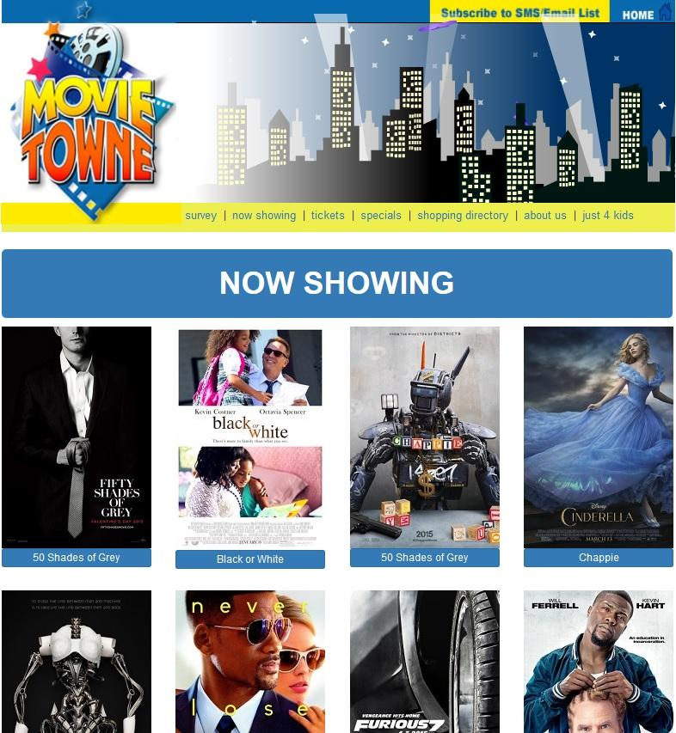

The screenshot below depicts a partial view of an incomplete and possible prototype for the movie details and purchasing web page. Features of this page includes:

* An enlarge title of the movie
* A movie poster
* A movie preview
* A link to the Inter Movie Database
* A link to the review section of the page
* Options for selecting date and time of movie

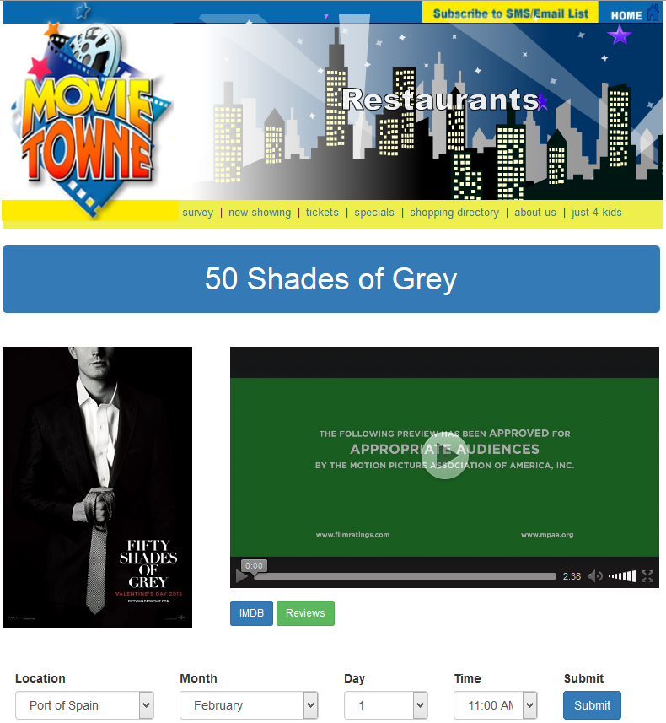

The screenshot below depicts a partial view of an incomplete and possible prototype for the lower part of the movie details and purchasing web page. Features include:

* Viewable receipt details
* Review section

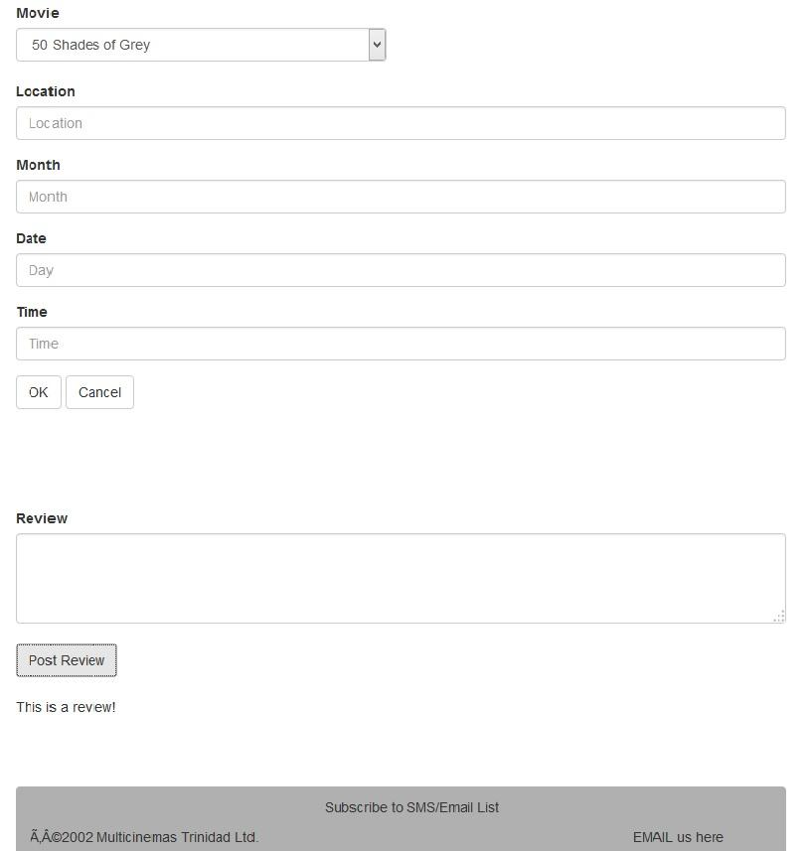

**Table 2 Showing Staff Activity**

Staff Task includes:

* Update Website
* View Transactions

|  |  |  |  |  |
| --- | --- | --- | --- | --- |
| Task No. | Task | Input | Output | Comments |
| 1 | Update Website | * Pictures * Movie Information * Movie Preview | Updates Website | Staff will keep website updated with new movies in a timely fashion. |
| 2 | View Transaction |  | Purchase Details | Staff may review transactions. |

### Document the Current Tasks

|  |  |  |  |  |
| --- | --- | --- | --- | --- |
|  | Mandatory task | Desirable task | Could Include | Exclude |
| Customer | (1) view the following:  -movie listings  -price  -time  (2) select a movie  (3) select date, time of movie  (4) purchase tickets if available  (5) choose and reserve seat | (1)give a review of a movie recently viewed (2) give a critic of your cinema experience  (3)post suggestions that may assist MovieTowne in enhancing customer experience | - | (1)chatroom with other customers |
| Worker | (1) update movie listings every week (2) update prices if necessary  (3) maintain page in order to post updates or promotions pertaining to customers | (1) can remove/band a customer due to ill behaviour if management sees fit  (2) can respond to customer comments if necessary | - | - |

### Describe each task

Task 1: Creating user account

Task Descriptions

|  |  |
| --- | --- |
| Preceding Tasks: | 1. Open the website. 2. Select the Now Showing section |
| Succeeding Tasks: | 1. Navigate website 2. View current showing movies 3. Select movie 4. Choose seating 5. Purchase tickets for movie |
| Task Interruptions | 1. Entering invalid information while signing up for an account |
| Performed By: | Customers |
| Task Products: | User credentials and credit card information - Will be stored in a database |
| Common Performance Problem: | Time taken for registration process to occur. |
| User Problems: | User registers with incorrect information |
| Potential Solution: | Adequate tooltips and proper form design will assist users with registration. |
| Work environment: | User’s computer or public computer |

**Task Detail Table**

|  |  |  |  |  |  |
| --- | --- | --- | --- | --- | --- |
| Task # | Task | Frequency | Display Requirements | Input Requirements | Comments |
| 1.1 | Navigate to top of website | Low | Hyperlink from search engine or direct typing of address in address bar | Scrolling, Clicking |  |
| 1.2 | Click create account | Low | Hyperlink | Scrolling, Clicking |  |
| 1.3 | Enter necessary information | Low | Form | Scrolling, Clicking, Typing |  |
| 1.4 | Commit request for account | Low | Click | Clicking |  |

Task 2: Sign in with account

Task Description

|  |  |
| --- | --- |
| Preceding Tasks: | 1. Open the website. |
| Succeeding Tasks: | 1. Select movie 2. Select seats 3. Purchase tickets |
| Task Interruptions | Submit information by accident |
| Performed By: | Customers |
| Task Products: | Grants the user member access, enabling the purchase of tickets |
| Common Performance Problem: | Possible long load times |
| User Problems: | User forgets password |
| Potential Solution: | Password reset option? |
| Work environment: | User’s computer or public computer |

**Task Detail Table**

|  |  |  |  |  |  |
| --- | --- | --- | --- | --- | --- |
| Task # | Task | Frequency | Display Requirements | Input Requirements | Comments |
| 2.1 | Navigate to top of website | Low | Hyperlink | Scrolling, Clicking |  |
| 2.2 | Click Log in | Low | Hyperlink | Scrolling, Clicking |  |
| 2.3 | Enter credentials | High | Form | Scrolling, text |  |
| 2.4 | Submit information | Low | Button | Click |  |

Task 3: Select movie

Task Description

|  |  |
| --- | --- |
| Preceding Tasks: | 1. Open the website. |
| Succeeding Tasks: | 1. Choose seat 2. Purchase tickets for movie |
| Task Interruptions | Selecting wrong movie or wrong section |
| Performed By: | Customers |
| Task Products: | Displays movie listing to screen. |
| Common Performance Problem: | Invalid/broken hyperlink to movie |
| User Problems: | User selects wrong movie |
| Potential Solution: | Descriptive layout and proper labeling of headers will be utilized |
| Work environment: | User’s computer or public computer |

**Task Detail Table**

|  |  |  |  |  |  |
| --- | --- | --- | --- | --- | --- |
| Task # | Task | Frequency | Display Requirements | Input Requirements | Comments |
| 3.1 | Navigate to top of website | Low | Hyperlink | Scrolling, Clicking |  |
| 3.2 | Click on Now showing | Low | Hyperlink | Scrolling, Clicking |  |
| 3.3 | Scroll to find movie | High | Images | Scrolling |  |
| 3.4 | Select Movie | Low | Image | Click |  |

Task 4: Select seat

Task Description

|  |  |
| --- | --- |
| Preceding Tasks: | 1. Open the website. 2. Log in 3. Browse and locate movie 4. Select seats to be purchased |
| Succeeding Tasks: | 1. Browse movies |
| Task Interruptions | Selecting wrong seats |
| Performed By: | Customers |
| Task Products: | Displays movie listing to screen. |
| Common Performance Problem: |  |
| User Problems: | Selecting wrong seat |
| Potential Solution: | Ample selection area shall ensure that a user won't misclick a seat. Also proper layout will ensure that a user selects the correct seat in relation to the cinema screen. |
| Work environment: | User’s computer or public computer |

**Task Detail Table**

|  |  |  |  |  |  |
| --- | --- | --- | --- | --- | --- |
| Task # | Task | Frequency | Display Requirements | Input Requirements | Comments |
| 4.1 | Navigate to top of website | Low | Hyperlink | Scrolling, Clicking |  |
| 4.2 | Click the Now Showing section | Low | Hyperlink | Scrolling, Clicking |  |
| 4.3 | View movies by scrolling | High | Images and text | Scrolling |  |

Task 5: Purchase tickets

Task Description

|  |  |
| --- | --- |
| Preceding Tasks: | 1. Open the website. |
| Succeeding Tasks: | 1. Select movie |
| Task Interruptions | Selecting wrong seats |
| Performed By: | Customers |
| Task Products: | Displays movie listing to screen. |
| Common Performance Problem: |  |
| User Problems: | Selecting wrong seat |
| Potential Solution: | Ample selection area shall ensure that a user won't misclick a seat. Also proper layout will ensure that a user selects the correct seat in relation to the cinema screen. |
| Work environment: | User’s computer or public computer |

**Task Detail Table**

|  |  |  |  |  |  |
| --- | --- | --- | --- | --- | --- |
| Task # | Task | Frequency | Display Requirements | Input Requirements | Comments |
| 4.1 | Navigate to top of website | Low | Hyperlink | Scrolling, Clicking |  |
| 4.2 | Click the Now Showing section | Low | Hyperlink | Scrolling, Clicking |  |
| 4.3 | View movies by scrolling | High | Images and text | Scrolling |  |

Task 6: Give review

Task Description

|  |  |
| --- | --- |
| Preceding Tasks: | 1. Open the website. |
| Succeeding Tasks: | 1. Browse movies 2. Select movie 3. Choose seating 4. Purchase tickets |
| Task Interruptions | Submitted review before it is completed |
| Performed By: | Customers |
| Task Products: | Displays reviews for other customers to view |
| Common Performance Problem: | Rating isn’t selected before submission |
| User Problems: | Submitted review before it is completed |
| Potential Solution: | Prompts to ensure the user has rated and stated complete text will be made available |
| Work environment: | User’s computer or public computer |

Task Detail Table

|  |  |  |  |  |  |
| --- | --- | --- | --- | --- | --- |
| Task # | Task | Frequency | Display Requirements | Input Requirements | Comments |
| 6.1 | Navigate to top of website | Low | Hyperlink | Scrolling, Clicking |  |
| 6.2 | Click the Now Showing section | Low | Hyperlink | Scrolling, Clicking |  |
| 6.3 | View movies by scrolling | High | Images and text | Scrolling |  |
| 6.4 | Select movie | Low | Images | Clicking |  |
| 6.5 | Click add review | Low | Tab/button | Clicking |  |
| 6.6 | Add review | Medium | Form | Text |  |
| 6.7 | Submit review | Low | button | Clicking |  |

### Document Problems and Opportunities

Problems:

* Presently, MovieTowne’s website only permits browsing to its users. This includes browsing of its current and upcoming movies as well as information pertaining to its surrounding stores.
* If a potential customer would like to purchase a movie ticket, he/she would have to go to the establishment to do so. This can be inconvenient as tickets may be sold out upon one’s arrival to purchase them.
* Currently, the website is not ideally designed to appeal to potential customers.
* There is a subscription section on the website, however there is no assurance that one’s personal information would not be compromised.

Opportunities:

* In terms of its competitors, there are 2 other establishments with similar initiatives therefore by incorporating online ticketing into the website, MovieTowne can gain a competitive edge.
* Increase in sales and profits as a result of online ticket sales.
* Promote MovieTowne’s website through various social media platforms.
* Introduction of reserved seating which would allow customers to purchase tickets and reserve a seat. This would reduce the hassle of finding a good seat therefore revolutionizing the entire movie going process and making it much more appealing to the public.

### Develop use case scenarios

**Use Case 1: Browse Movies**

Actors: User

Type: Primary

Purpose: To browse various movies on the site, both new and upcoming movies.

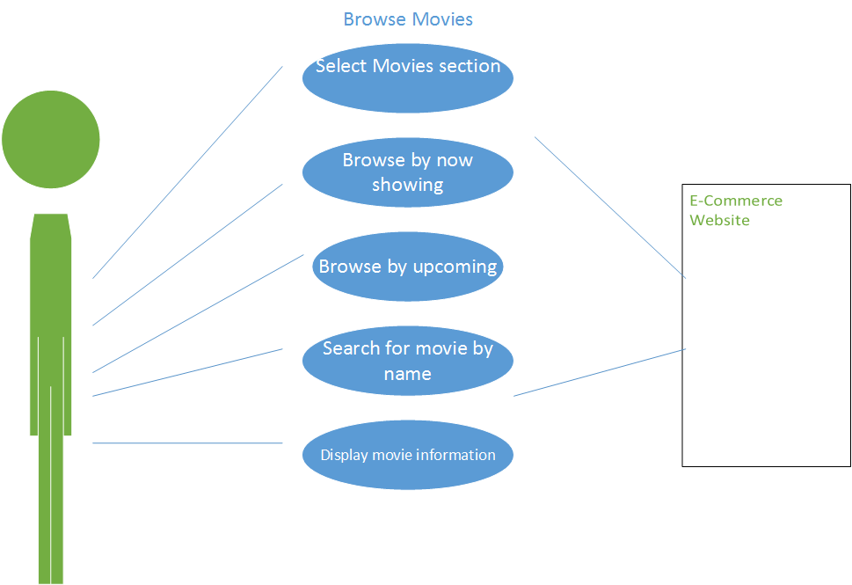

**Use Case 2: Check movie information**

Actors: User

Type: Primary

Purpose: To determine movie times and seating availability

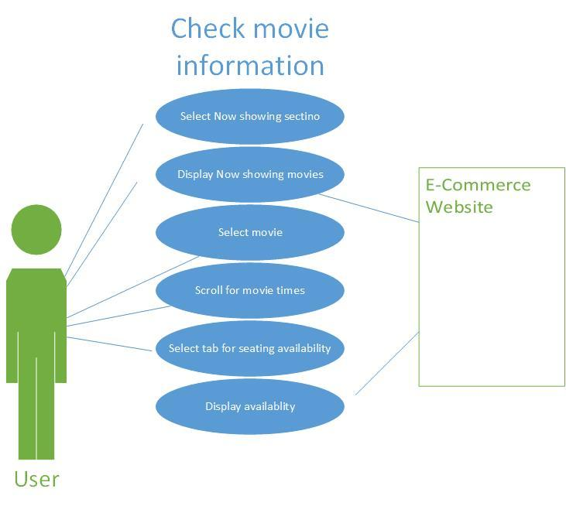

**Use Case 3: Creating an account**

Actors: User

Type: Primary

Purpose: To register as a legitimate online customer with the website

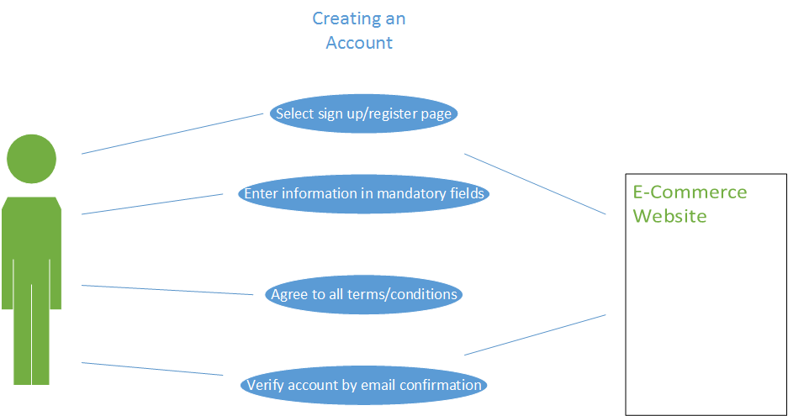

**Use Case 4: Log In**

Actors: User

Type: Primary

Purpose: To Login to the website using credentials in order to access member privileges

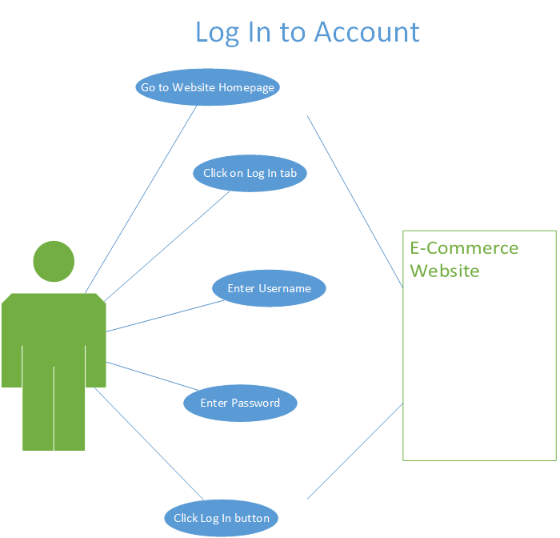

**Use Case 5: Make Purchase**

Actors: User

Type: Primary

Purpose: To purchase one or multiple e-tickets on a selected movie.

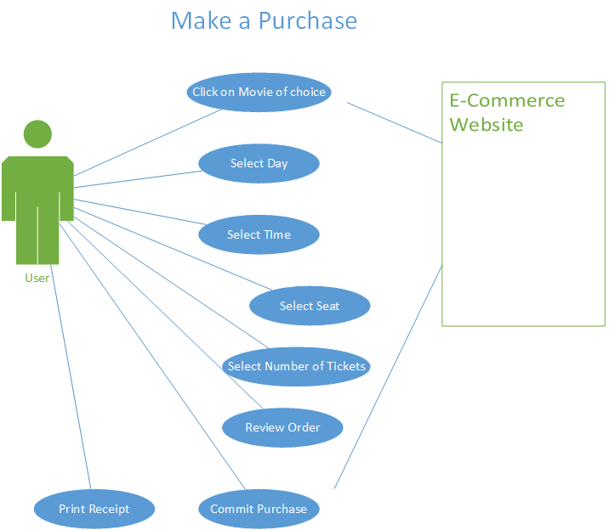

**Use Case 6: Give a Review**

Actors: User

Type: Primary

Purpose: To give a movie review

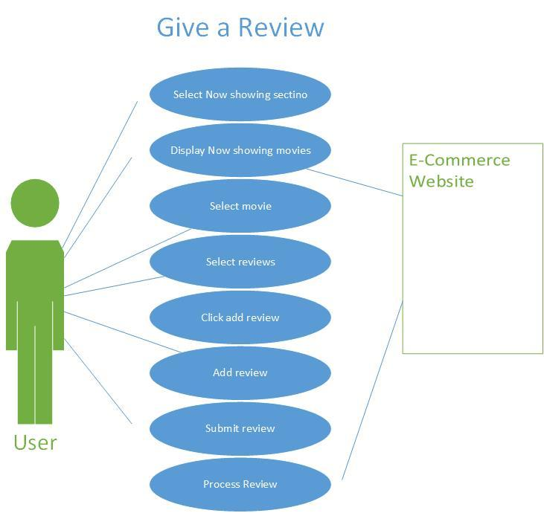

### Describe future tasks (1-2) if any

1. Develop a mobile application - this app will allow users to create a user account or use their current Movie Towne user login credentials to log in to the app. The app will provide same features as the website whereby users will be able to purchase tickets and reserve seats using their mobile devices.
2. Implement a “recommended for you” page which stores the movie tickets purchase history of a user and recommends movies that a user may like based on previous purchases.